Workgroup C1.067

Planning and progress report – D04

26/05/2025

Tudor Cristian Lacatus Cosma [- ionlac@alum.us.es](mailto:-%20ionlac@alum.us.es)

Table of Contents

INTRODUCTION 4

PLANNING 5

Tasks Performed: 5

Screenshots: 13

Budget: 14

PROGRESS 15

Progress Report: 15

Conflicts 15

Cost Comparison 15

CONCLUSIONS 16

BIBLIOGRAPHY 17

Executive Summary:

The following document addresses the planning and progress of the tasks regarding the individual requirements of Student#2 of the workgroup C1.067 during the time period of the fourth deliverable of the subject.

Revision Table

|  |  |  |
| --- | --- | --- |
| Revision Number | Date | Description |
| 1.0 | 26/05/2025 | Initial version of the planning and progress report |
|  |  |  |
|  |  |  |

# INTRODUCTION

This report offers a comprehensive overview of the tasks accomplished to fulfill the requirements of the specified deliverable. It features a structured list of tasks that includes titles, descriptions, assignees, and both planned and actual time spent. Key moments in the development process are illustrated with accompanying screenshots, in line with the established working methodology.

# PLANNING

## Tasks Performed:

**Title:** Task 167/T1 - Produce as a complete test suite as possible for Requirement #29

**Description:** Check that the test suite is complete.

**Assignee/s:** Raul Calero Capote (RauruGW in GitHub)

**Role/s:** Tester

**Expected Time:** 0.25 H

**Time Spent:** 0.1 H

**Title:** Task 167 - Produce as a complete test suite as possible for Requirement #29

**Description:** Produce as a complete test suite as possible for Requirement #29 ensuring that the API is properly mocked.

**Assignee/s:** Tudor Cristian Lacatus Cosma (tcosma in GitHub)

**Role/s:** Developer

**Expected Time:** 1 H

**Time Spent:** 0.35 H

**Title:** Task 159/T1 - Provide a link to your planning dashboard in GitHub

**Description:** Provide a link to your planning dashboard in GitHub to review the tasks, their current status, and your schedule.

**Assignee/s:** Raul Calero Capote (RauruGW in GitHub)

**Role/s:** Tester

**Expected Time:** 0.25 H

**Time Spent:** 0.05 H

**Title:** Task 159 - Provide a link to your planning dashboard in GitHub

**Description:** Provide a link to your planning dashboard in GitHub to review the tasks, their current status, and your schedule.

**Assignee/s:** Tudor Cristian Lacatus Cosma (tcosma in GitHub)

**Role/s:** Developer

**Expected Time:** 0.25 H

**Time Spent:** 0.1 H

**Title:** Task 158/T1 - Create appropriate indices for your entities

**Description:** Check that the indices are well-defined.

**Assignee/s:** Javier Arellano López (javiarellanoo in GitHub)

**Role/s:** Tester

**Expected Time:** 0.5 H

**Time Spent:** 0.25 H

**Title:** Task 158 - Create appropriate indices for your entities

**Description:** Create appropriate indices for your entities, if required.

**Assignee/s:** Tudor Cristian Lacatus Cosma (tcosma in GitHub)

**Role/s:** Developer

**Expected Time:** 1 H

**Time Spent:** 0.5 H

**Title:** Task 157/T1 - Produce a testing report

**Description:** Check the testing report of student#2

**Assignee/s:** Raul Calero Capote (RauruGW in GitHub)

**Role/s:** Tester

**Expected Time:** 1 H

**Time Spent:** 2 H

**Title:** Task 157 - Produce a testing report

**Description:** Produce a testing report

**Assignee/s:** Tudor Cristian Lacatus Cosma (tcosma in GitHub)

**Role/s:** Developer

**Expected Time:** 1 H

**Time Spent:** 2 H

**Title:** Task 154/T1 - Produce a linting report

**Description:** Check that the linting report is well-defined.

**Assignee/s:** Javier Arellano López (javiarellanoo in GitHub)

**Role/s:** Tester

**Expected Time:** 1 H

**Time Spent:** 0.25 H

**Title:** Task 154- Produce a linting report

**Description:** Produce a linting report

**Assignee/s:** Tudor Cristian Lacatus Cosma (tcosma in GitHub)

**Role/s:** Developer

**Expected Time:** 2 H

**Time Spent:** 1 H

**Title:** Task 153/T1 - Perform 5 mutations in the code

**Description:** Check that the mutations are well defined

**Assignee/s:** Javier Arellano López (javiarellanoo in GitHub)

**Role/s:** Tester

**Expected Time:** 0.25 H

**Time Spent:** 0.1 H

**Title:** Task 153- Perform 5 mutations in the code

**Description:** Perform 5 mutations in the code

**Assignee/s:** Tudor Cristian Lacatus Cosma (tcosma in GitHub)

**Role/s:** Developer

**Expected Time:** 1 H

**Time Spent:** 0.40 H

**Title:** Task 151/T1- Produce a test suite for Requirements #8 and #9

**Description:** Review that the test suite is running without any problem, and that has reviews most of safe and hacking scenarios.

**Assignee/s:** Miguel Prado Jiménez (mpradoj04 in GitHub)

**Role/s:** Tester

**Expected Time:** 0.25 H

**Time Spent:** 0.25 H

**Title:** Task 151 - Produce a test suite for Requirements #8 and #9

**Description:** Produce a test suite for Requirements #8 and #9 (Operations by Customer on Bookings and Passengers)

**Assignee/s:** Tudor Cristian Lacatus Cosma (tcosma in GitHub)

**Role/s:** Developer

**Expected Time:** 28 H

**Time Spent:** 30 H

**Assignee/s:** Tudor Cristian Lacatus Cosma (tcosma in GitHub)

**Role/s:** Developer

**Expected Time:** 1 H

**Time Spent:** 0.75 H

**Title:** Planning and progress report

**Description:** Write a planning and progress report

**Assignee/s:** Tudor Cristian Lacatus Cosma (tcosma in GitHub)

**Role/s:** Proyect Manager

**Expected Time:** 0,5 H

**Time Spent:** 1 H

**Title:** Analysis report

**Description:** Write an analysis report

**Assignee/s:** Tudor Cristian Lacatus Cosma (tcosma in GitHub)

**Role/s:** Analyst

**Expected Time:** 0,5 H

**Time Spent:** 1 H

## Screenshots:

The following screenshots were taken during different moments of the Deliverable, showcasing different stages of the methodology proposed by the subject.

**Tasks in the middle of the process:**

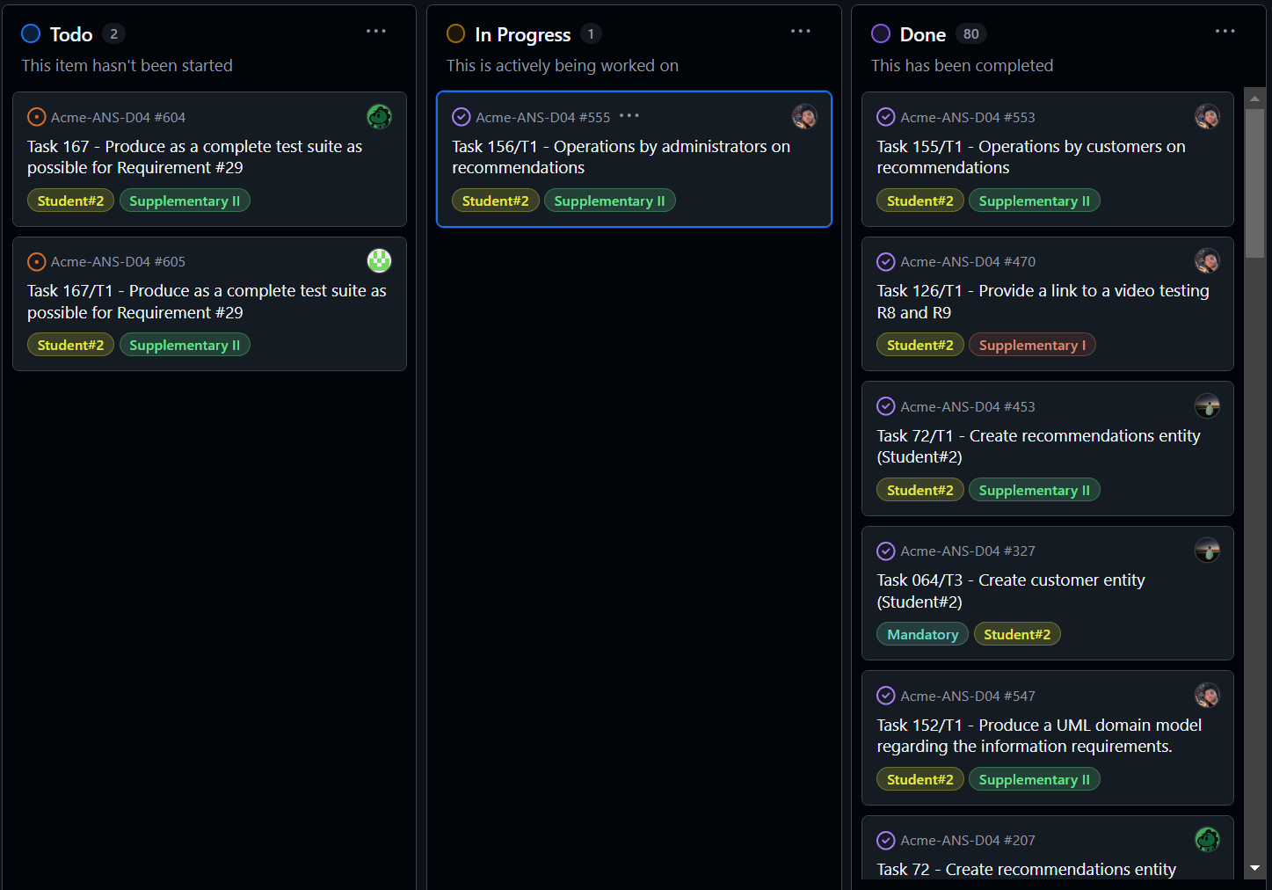

**Tasks in the done lane:**

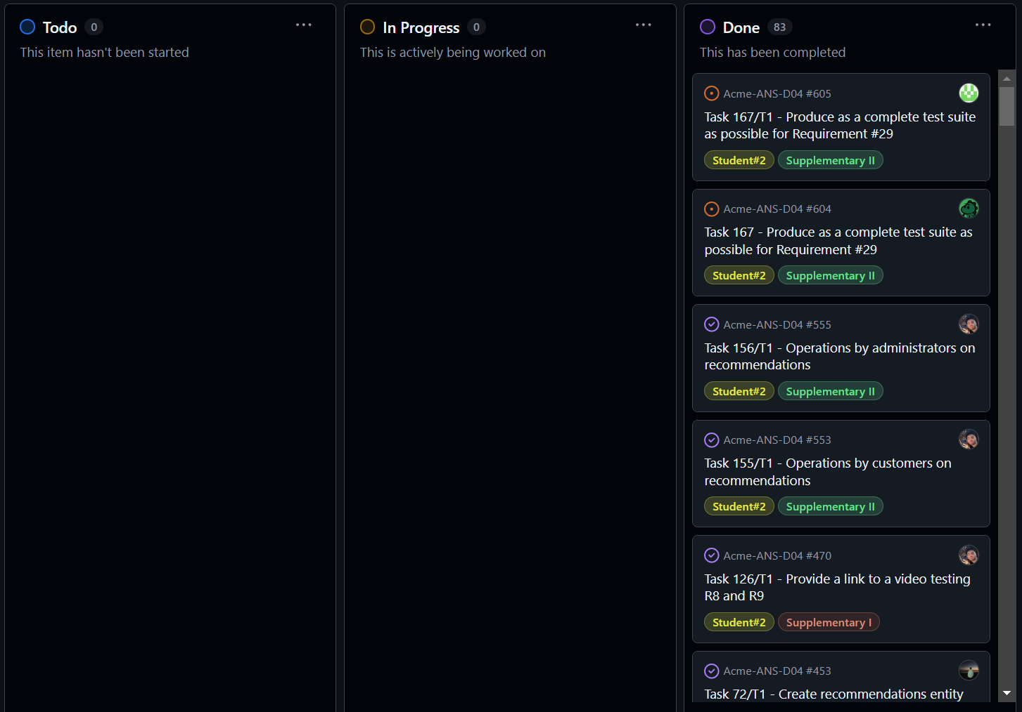

## Budget:

The budget for Delivery 04 includes the estimated hours per role, personnel costs, and amortization costs. Depending on the nature of the task, I have assumed a specific role, which is considered when calculating the budget. Personnel costs are determined based on the following hourly rates:

* Project Managers and analysts: €30.00 per hour
* Developers, testers, and other roles: €20.00 per hour

After summing the estimated times for each task, taking into account the assumed role, the final budget is obtained.

|  |  |  |  |
| --- | --- | --- | --- |
| Role | Hourly Rate (€) | Estimated time(hrs) | Estimated cost (€) |
| Project Manager | 30 | 0,5 | 15 |
| Analyst | 30 | 0,5 | 15 |
| Developer | 20 | 34,25 | 685 |
| Tester | 20 | 3,5 | 70 |
| Totals: |  | 38,75 | 785 |

The project requires the use of a laptop or a personal computer, valued at 1150€, which is amortized over three years (36 months, 4 weeks per month). Hence, the weekly amortization cost is the following:

Amortization cost per week = 1150/(36*4) = 7,98€

Since the fourth delivery has had a length of 7 weeks, we compute the amortization cost of this time period and add it to the final amount.

Thus, the cost is of 840,86€

# PROGRESS

## Progress Report:

This letter presents an overview of my performance in individual tasks, assessed in relation to the performance indicators outlined in the Charter Report. It also specifies the actions

I have undertaken accordingly. In reference to the "Actual Grade vs Expected Grade" indicator, my objective was to achieve the highest possible grade while maintaining positive performance metrics. As a member of group C1.067, I consistently attended all lectures and follow-up sessions, completed every assigned task within the original deadlines, and fulfilled the expectations established in the Charter Report.

## Conflicts

No conflicts have occurred during this time period.

## Cost Comparison

After completing the delivery, I will compare the estimated costs with the actual costs incurred. This includes the number of hours spent per role, personnel costs, amortization and the total cost difference.

|  |  |  |  |
| --- | --- | --- | --- |
| Role | Hourly Rate (€) | Real time(hrs) | Real cost (€) |
| Project Manager | 30 | 1 | 30 |
| Analyst | 30 | 1 | 30 |
| Developer | 20 | 34,35 | 687 |
| Tester | 20 | 3 | 60 |
| Totals: |  | 39,35 | 807 |

The project requires the use of a laptop or a personal computer, valued at 1150 €, which is amortized over three years (36 months, 4 weeks per month). Hence, the weekly amortization cost is the following:

Amortization cost per week = 1150/(36*4) = 7,98€

Since the fourth delivery has had a length of 7 weeks, we compute the amortization cost of this time period and add it to the final amount.

Thus, the cost is of 862,86€.

Taking a quick comparison to both costs, we see that we have obtained a lose of 22€. This indicates a wrong estimation effort.

# CONCLUSIONS

This report has presented a comprehensive overview of the execution phase, including objectives, allocated resources, and a cost analysis. The actual execution aligns closely with the estimated budget, with only a minor deviation in cost due to an underestimation of development hours.

No negative performance indicators were observed. Having maintained consistent participation and task completion, and given the absence of conflicts or delays, it can be concluded that my individual performance has been positive and in accordance with the standards set forth in the Charter Report.

# BIBLIOGRAPHY

Intentionally blank